**FilmOracle Guides**

**Web Map:**

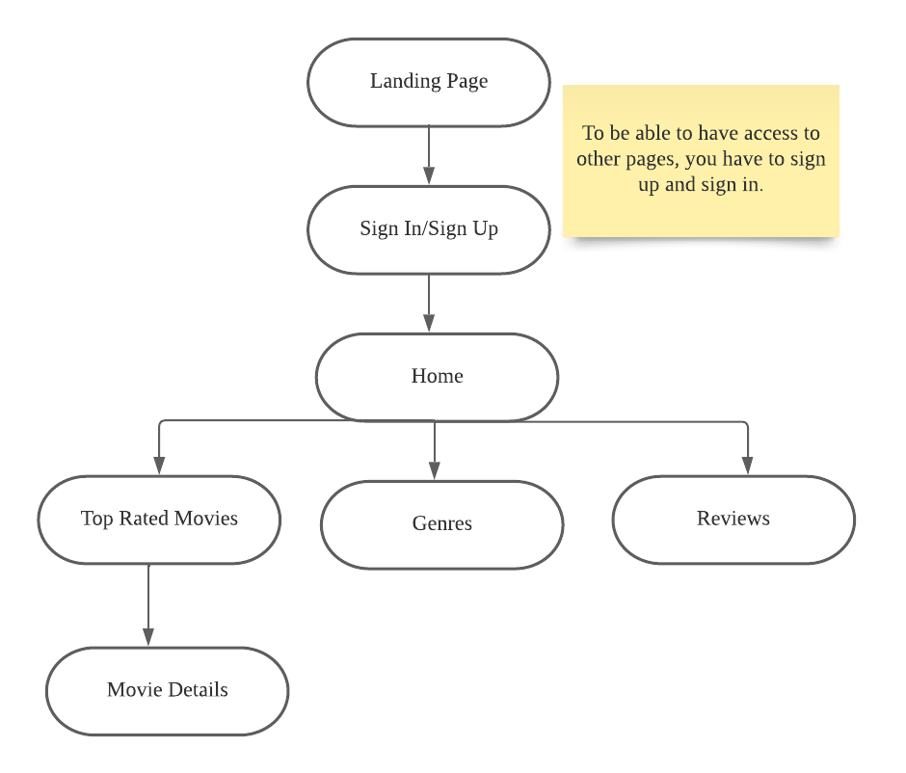

**Design Guide**

**Introduction**

Welcome to FilmOracle, the ultimate movie searching website designed for movie enthusiasts who are looking for a comprehensive database of movies and reviews. Our website has been recently updated to include a sign in and sign up process, allowing users to access the full range of features on our site.

By signing up, users can explore our ranked movies webpage and leave reviews and opinions on the movies they've seen. This creates an interactive and engaging experience for our users, allowing them to connect with other movie enthusiasts and engage in discussions about their favorite films.

At FilmOracle, we understand the importance of having a user-friendly and visually appealing website. That's why we've developed a design style guide that focuses on providing a seamless and intuitive user experience. Our website features a modern and sleek design with a clean color scheme and layout, making it easy for users to find the information they need.

We have also made it a priority to optimize our website for both desktop and mobile devices, ensuring that users can access our database and community from anywhere. By utilizing the latest web development technologies, we are able to offer a fast and responsive website that delivers the best possible user experience.

Our website is built with the TMDB API, which guarantees that our movie database is comprehensive, up-to-date, and accurate. We are committed to providing movie enthusiasts with the latest information and opinions on their favorite films, as well as a platform to explore and discover new movies.

We believe that FilmOracle is the ultimate destination for movie lovers, offering a comprehensive database of movies and reviews, as well as an interactive and engaging community of movie enthusiasts. We hope that you'll join us and experience all that our website has to offer.

**Brand Identity:**

Logo:

The primary logo of FilmOracle features a sleek, modern design with the name of the brand in bold, capitalized letters. The logo is predominantly white with a black background, adding a touch of elegance to the design. The five words below the name FILMORACLE is our tagline of the website.

文本, 徽标

Tagline:

Our tagline is "Explore movies, share your thoughts" which encapsulates the purpose of our website - to provide movie lovers with a platform to explore and discover new films to love.

Mission and Vision:

Our mission is to provide movie lovers with a comprehensive database of movies and reviews, as well as an interactive community of like-minded individuals who share a passion for films. We aim to be the ultimate destination for movie lovers, providing them with the latest information and opinions on their favorite movies.

Our vision is to revolutionize the way people discover and experience movies. We want to create a platform that is accessible to all movie lovers, regardless of their experience or expertise, and to provide them with a personalized and enjoyable movie search experience.

Brand Voice:

Our brand voice is conversational, informative, and engaging. We want to create content that is accessible to all, whether they are casual movie fans or serious film critics. Our tone is friendly and approachable, yet knowledgeable and authoritative. We strive to make our users feel welcome and valued, and to foster a sense of community among our users.

**Color Palette**

* 1. Primary Colors: List the primary colors with their hex codes.

• White (#ffffff) - Used for backgrounds and primary text.

• Black (#000000) - Used for body text and accent elements.

* 1. Secondary Colors: List the secondary colors with their hex codes.

• Light Grey (#fffefe) - Used for backgrounds and text accents.

• Dark Grey (#686868) - Used for text and accent elements.

* 1. Accent Colors: List the accent colors with their hex codes.

• Green (#669767) - Used for positive elements.

• Orange (#FFA500) - Used for warnings and alerts.

• Red (#9F1F1F) - Used for errors and negative elements.

* 1. Usage Guidelines: Explain how and when to use each color.

• Use white and black as the primary fonts color for all pages.

• Use light grey as a secondary background color for specific sections or elements.

• Use dark grey for text and accent elements such as headings or icons.

• The majority of the website colors are mostly dark-toned because our theme is a movie website, so the first impression given to the user is also related to the cinema. The most important thing when watching a movie is immersion in it, so a dark color scheme design will give the user a sense of familiarity.

**Typography**

* 1. ypeface(s): List the typefaces used and their roles (e.g., headings, body text, etc.).

• Poppins, Mynerve - Used for headings and body text.

• Ubuntu - Used for movie information.

• Alkatra – Used for navbar and footer bar

* 1. Font Sizes: Specify font sizes for various text elements.

• Body Text - 16px

• Heading 1 - 48px

• Navbar – 24px

• Footer -24px

• Different font sizes for different text elements, with the heading using the largest font size, followed by the subheading and body text. This establishes a clear hierarchy of information and makes it easier for users to navigate the website.

* 1. Line Height: Define line heights for readability and visual hierarchy.

• Body Text - 1.5

• Headings - 1.2

• The given code uses different font weights for different text elements. The movie details use bold font weight, while the review form uses the default font weight.

* 1. Font Weights: Indicate which font weights to use for different text elements.

• Body Text - Regular (400)   
• Headings - Bold (700)

**Imagery and Icons**

Image Style:

The selected movie posters and illustrations should primarily focus on the combination of colors and characters. Some posters have a monotonous color scheme that may not be appealing enough. Therefore, the posters I consider should prominently feature the movie's title and the actors' expressions to make them more attractive to viewers.

Icon Style:

Describe the preferred style of icons (e.g., line icons, solid icons, etc.).

Icon selection, I try to choose designs that are simple because the website is focused on the movie theme and emphasizes the content of the movies. Icons serve as a tool to guide users' use of the website, so it is best to have icons that are clear and concise in expressing their functions.

Usage Guidelines:

Explain how and when to use images and icons.

I chose high-quality images High-quality images can enhance the visual appeal of the website and provide a professional look. And a consistent style of images and icons throughout the website. This can improve the visual appeal and provide a more professional look.

**Conclusion:**

In conclusion, FilmOracle is the ultimate destination for movie lovers, providing a comprehensive database of movies, rankings, and reviews, as well as an interactive community of movie enthusiasts. Our website was built with the goal of creating a seamless user experience, from our easy-to-use interface to our visually appealing and user-friendly design style guide.

One key feature of our website is the sign in and sign up process, which allows users to have access to the full range of features on our site. By creating an account, users can leave reviews, post opinions, and engage in discussions with other movie enthusiasts, creating a sense of community and connection.

It is important for users to follow our design style guide, which has been carefully developed to ensure that our website is both aesthetically pleasing and functional. By adhering to our guidelines, users can make the most of our website and enjoy a seamless and enjoyable movie search experience.

At FilmOracle, we are passionate about movies and committed to providing the best possible experience for our users. Whether you are a casual movie fan or a serious film critic, we have something to offer you. We hope that you will join our community of movie lovers and discover all that FilmOracle has to offer.

**user interface functionality guide**

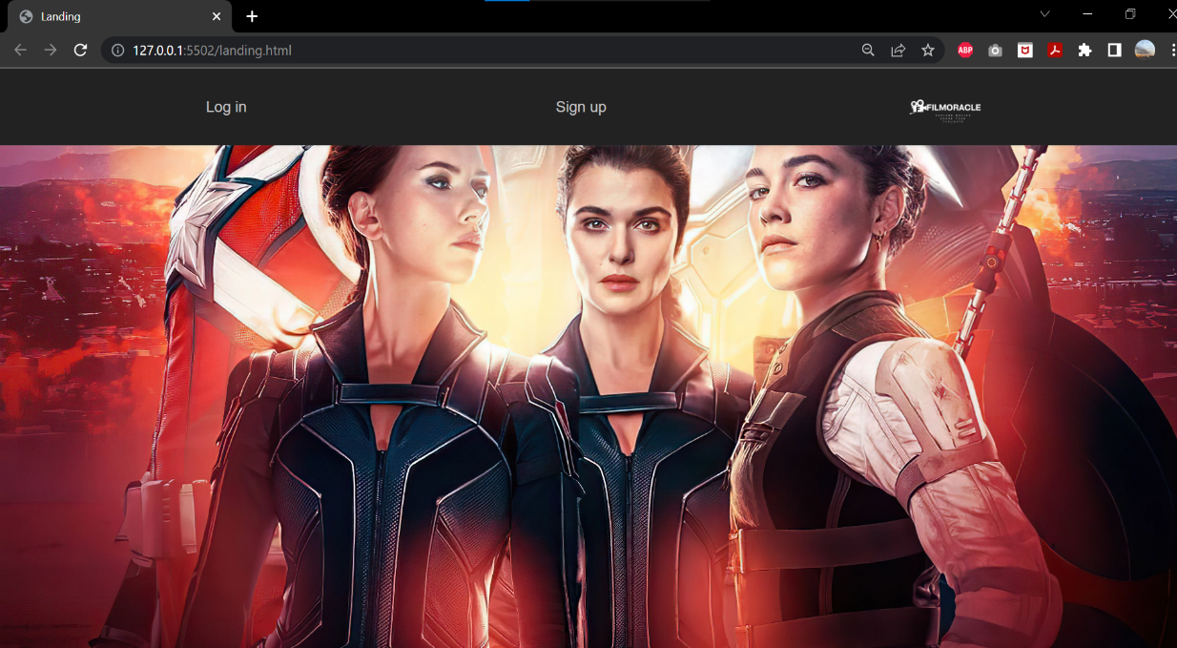

**Landing Page:**This is the first page the visitors are going to see.

In order to have access to the webpages, visitors have to sign-up and sign in.

**Sign-up Page:**Visitors sign-up here. It will redirect to the sign-in page.

**Sign-in Page:**Visitors sign in here after signing up. Once you sign-in, it will take them to home page.

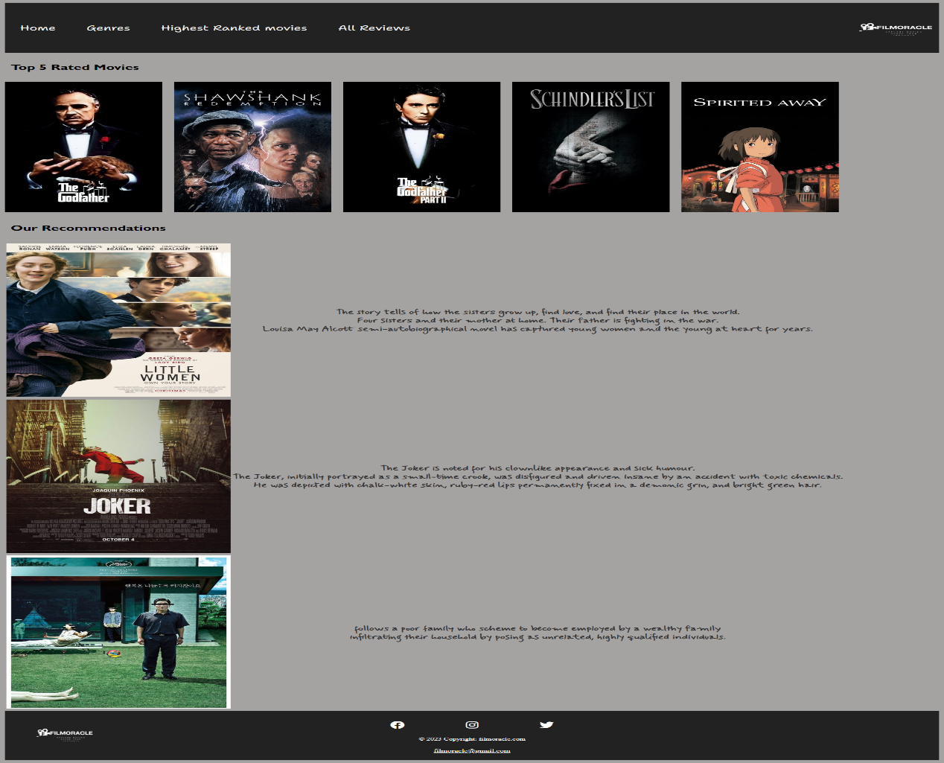

**Home Page:**

Visitors have the full access to all the webpages.

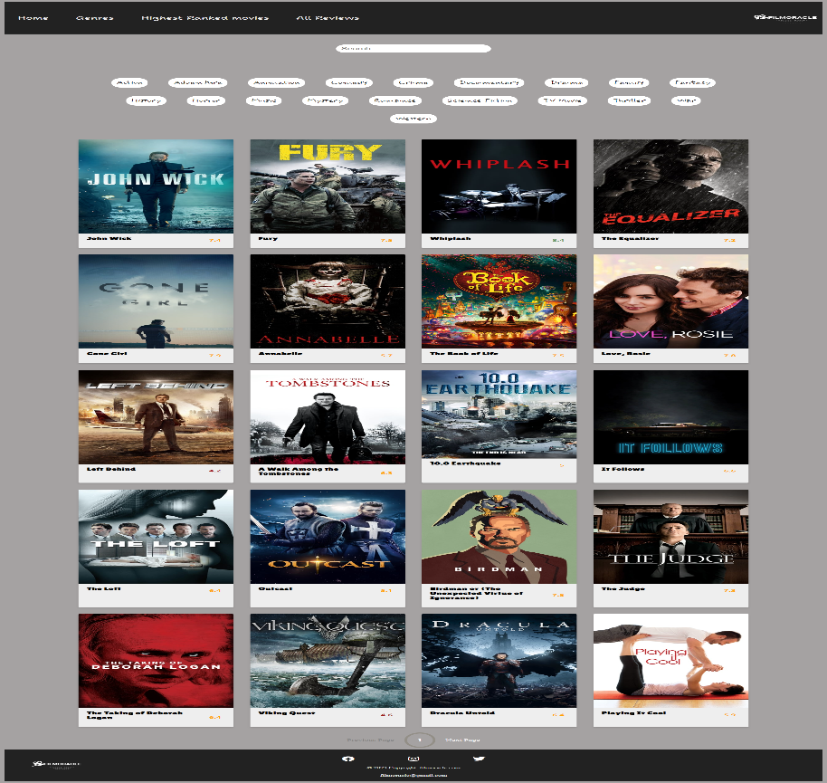

**Genres:**

Visitors can search for the movies they like or filter movies by genres.

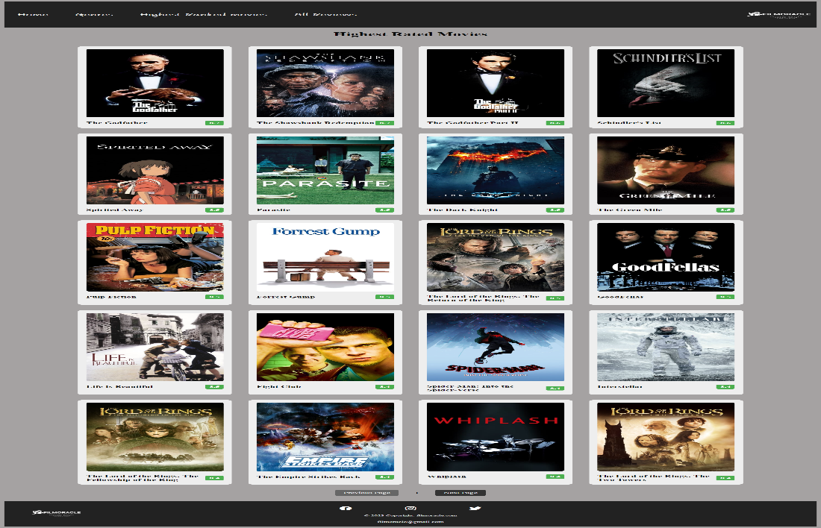

**Highest Ranked Movies:**

The movies here are order by rank. Visitors can find the top movies and they can explore the details of each movie when clicking on the poster of the each movie.

**Movie Details:**Once the movie is clicked on the highest ranked page, it will take them to the webpage with all the movie details and they can leave their reviews about the movie.

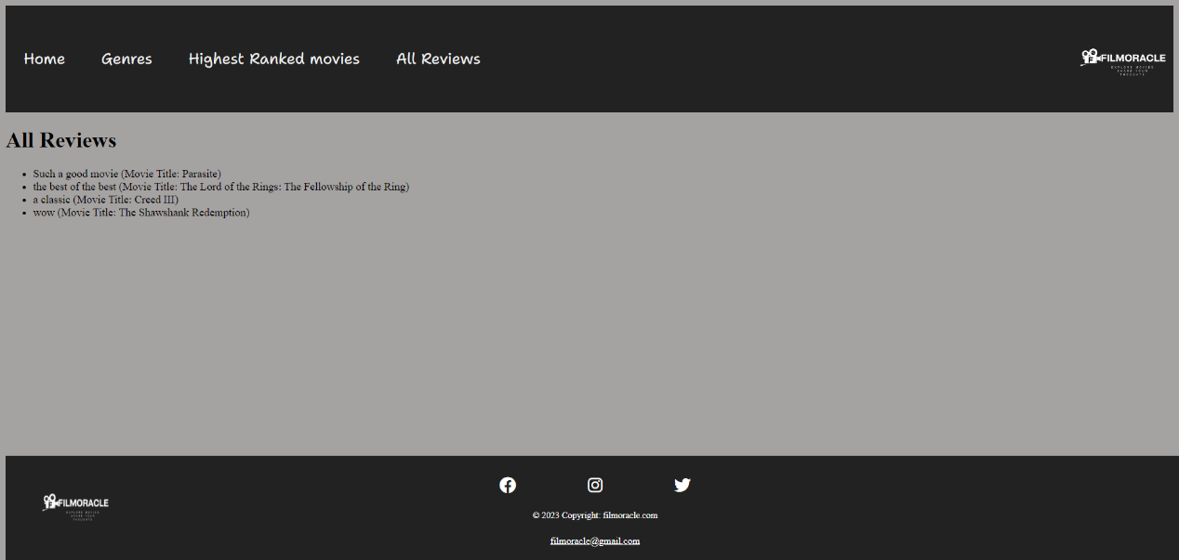

**All Reviews:**Once is review is entered, the visitor would be directed to the all reviews page showing all the reviews from other visitors.